# 

## 

## 

## 

# **MOVIE TICKETING SYSTEM PROJECT**

**[HIGH LEVEL REQUIREMENT DOCUMENT]**

*Rev 1*

## 

**TEAM MEMBERS:**

|  |  |  |
| --- | --- | --- |
| 1) HENG CHIANG YONG | 2) JONY LIU | 3) KOH KIM KANG |
| 4) ONG KAH SONG (ANDY) | 5) PHANG KANG CHENG | 6) PRISCILLA LOW YI XIAN |
| 7) TAN HAN WEN KENNETH | 8) TAN HWEE SONG ANDREW | 9) WOOI YEONG CHENG |
| 10) ANG WEIXUAN DESMOND | 11) CHEONG SI SIEN | 12) TIAN KAIWEN |

## **Project Estimated Period/ Duration**

Project Period : **(start date) to (handover date)**

Duration : **3 months**

## 

## **The Goal**

*“To create a Cinema Booking System to serve the Client’s Customers with a seamless service experience. At the same time to better manage the Client’s Customer data, to increase operational efficiency and provide cost savings to the Client.”*

## **To Build (What?)**

*“To build a Cinema Booking System which gives the Client’s Customers a seamless experience throughout their entire transaction journey.*

*The said system is also to possess a working database which will store Client’s Customers data for future marketing purposes, as well as other promotional activities to be carried out at the Client’s discretion.*

*Together, the system, database and separate complementary e-payment tools will help to better manage the Client’s Customer bookings, experience and reduce running costs.”*

*If purchasing is to be done online*

1. *Database*
2. *Website*
3. *E-ticket system*
4. *E-payment system*

*If purchasing is to be done offline*

1. *Database*
2. *User Interface for Inputs and Outputs*
3. *Ticket Printing System (Physical Ticket Issuance)*
4. *POS System*

## **Benefits (Why?)**

1. *Increased efficiency to reduce manpower requirements*
2. *Greater reach to customers by providing an online avenue for bookings*
3. *Consolidated data for marketing purposes - use of database*
4. *Real time analysis of movies for popularity, rating, etc - use of database data*
5. *Better user experience by reducing queue times*

## 

## **Proposed Tools to be used**

1. *Software Development Tools*
   1. *Oracle SQL Developer IDE*
   2. *Apache Netbean IDE*
2. *Hardware Development Tools*
   1. *Laptop/PC*

## 

## **Software Requirements for the Project**

1. *Frontend: HTML/CSS/Javascript*
   1. *Visual Studio*
   2. *Visual Studio Code*
   3. *Atom*
2. *Backend: Java/Oracle DB*
   1. *Oracle SQL Developer IDE*
   2. *Apache Netbean IDE*
   3. *IntelliJ*
   4. *Eclipse*
   5. *Python*

## **Hardware Requirements for the Project**

1. *Desktops*
2. *Laptops*
3. *Tablets*
4. *Mobile phones on Windows/Android/Apple*

## **System(s) the Project expected to Operate on**

1. *Windows*
2. *macOS*
3. *Linux/Unix??*
4. *Android*
5. *iOS*

## 

## **Coding and Naming Conventions**

1. *PascalCase - Chosen option*
2. *camelCase*
3. *Snake_case*
4. *kebab-case*

*References:* <https://www.oracle.com/java/technologies/javase/codeconventions-introduction.html>

## 

## **UI (mockup) [WIP]**

*Image below is used as an illustration. Outcome may look completely different.*

**https://dribbble.com/shots/6792423-Ticket-Booking-App-UI**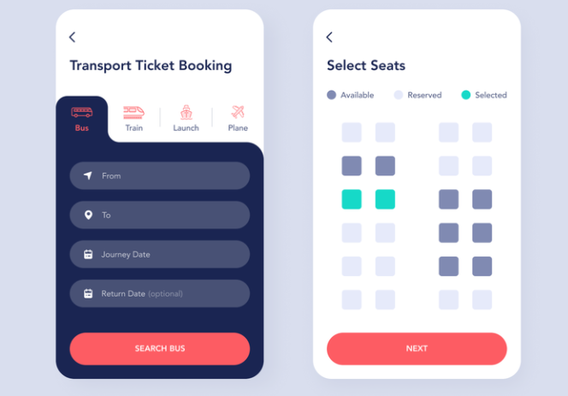

## **Use Case Design**

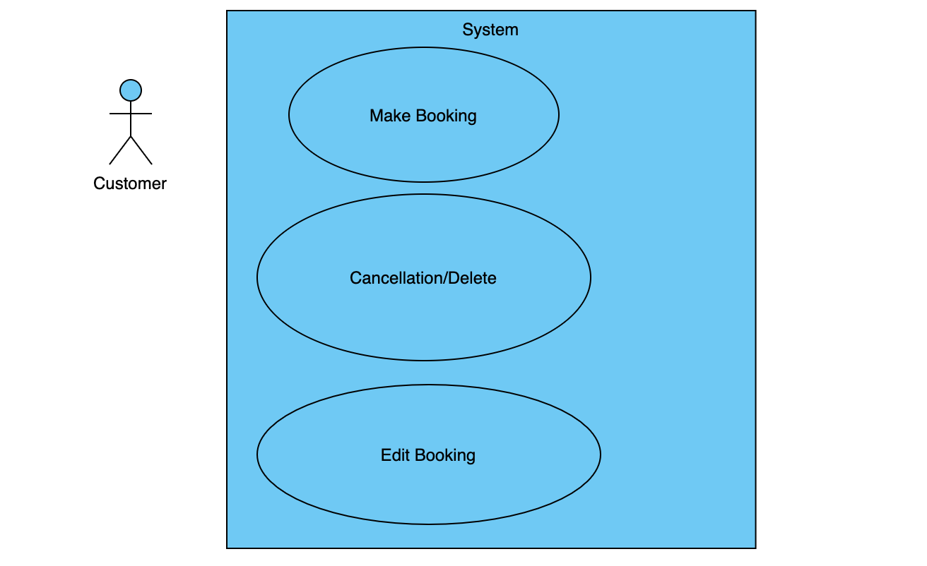

## 

## 

## 

## 

## 

## 

## **Flow Diagram**

1. Make Booking

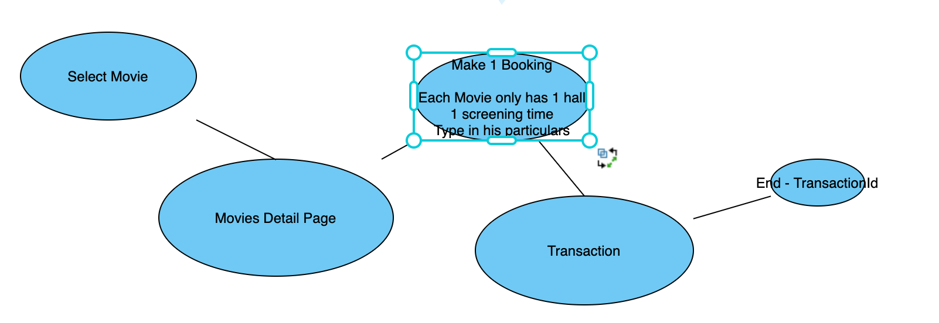

1. Cancel Booking

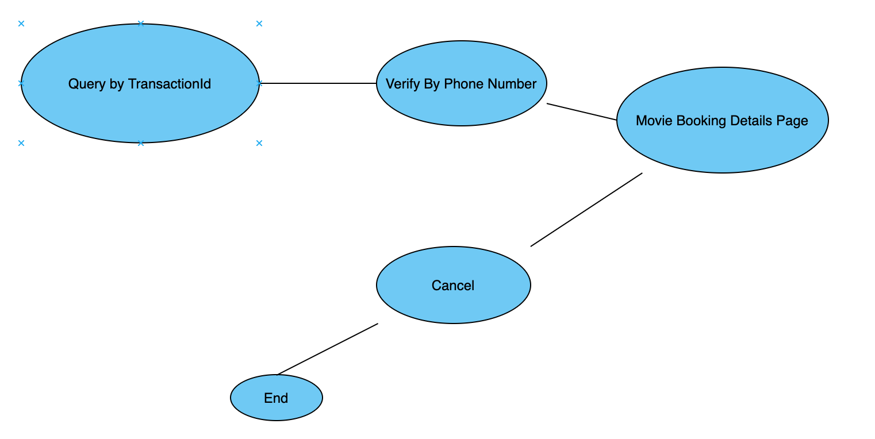

1. Edit Booking

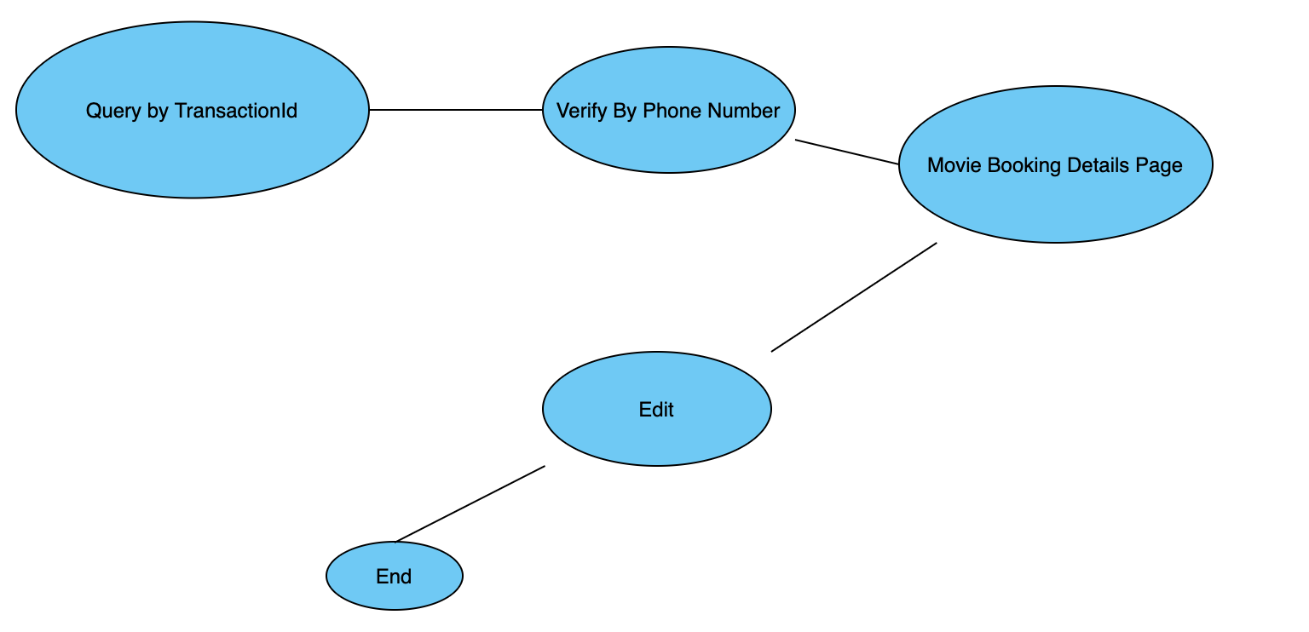

## **ER Diagram**

## 

## **Database Design**

|  |  |  |  |
| --- | --- | --- | --- |
| **Booking** | | | |
| Data | Datatype | Constraint | Nullable |
| Booking ID | INT | Primary key | Not Null |
| Booking Date | DATETIME |  | Not Null |
| Transaction ID | INT | Foreign key | Not Null |
| Screening ID | INT | Foreign key | Not Null |
| Seat_ID | INT | Foreign key | Not Null |

|  |  |  |  |
| --- | --- | --- | --- |
| **Movie** | | | |
| Data | Datatype | Constraint | Nullable |
| Movie ID | INT | Primary Key | Not Null |
| Movie Title | VARCHAR2(40) |  | Not Null |
| Rating_ID | INT | Foreign Key | Not Null |
| Language_ID | VARCHAR2(10) | Foreign Key |  |
| Movie Duration | INTERVAL |  |  |

|  |  |  |  |
| --- | --- | --- | --- |
| **Rating** | | | |
| Data | Datatype | Constraint | Nullable |
| Rating_ID | INT | Primary Key | Not Null |
| PG Rating | VARCHAR2(4) |  | Not Null |

|  |  |  |  |
| --- | --- | --- | --- |
| **Movie Language** | | | |
| Data | Datatype | Constraint | Nullable |
| Language_ID | INT | Primary Key | Not Null |
| Language | VARCHAR2(10) |  |  |

|  |  |  |  |
| --- | --- | --- | --- |
| **Screening Schedule** | | | |
| Data | Datatype | Constraint | Nullable |
| Screening ID | INT | Primary Key | Not Null |
| Movie ID | INT | Foreign key | Not Null |
| Branch ID | INT | Foreign key | Not Null |
| Hall_ID | INT | Foreign key | Not Null |
| Date | DATE |  | Not Null |
| Start time | TIME |  | Not Null |
| End time | TIME |  | Not Null |

|  |  |  |  |
| --- | --- | --- | --- |
| **Transactions** | | | |
| Data | Datatype | Constraint | Nullable |
| Transaction ID | INT | Primary Key | Not Null |
| Payment Mode | VARCHAR2(40) |  | Not Null |
| Payment Amount | FLOAT |  | Not Null |
| Customer ID | INT |  |  |

|  |  |  |  |
| --- | --- | --- | --- |
| **Branch Management** | | | |
| Data | Datatype | Constraint | Nullable |
| Branch ID (1) | INT | Primary Key | Not Null |
| Branch Name (GV Vivo) | VARCHAR2(40) |  | Not Null |
| Location ID | VARCHAR(20) | Foreign Key | Not Null |

|  |  |  |  |
| --- | --- | --- | --- |
| **Location** | | | |
| Data | Datatype | Constraint | Nullable |
| Location ID | INT | Primary Key | Not Null |
| Address | VARCHAR2(40) |  | Not Null |
| Contact Number | INT |  |  |

|  |  |  |  |
| --- | --- | --- | --- |
| **Hall Management** | | | |
| Data | Datatype | Constraint | Nullable |
| Hall_ID | INT | Primary Key | Not Null |
| Branch_ID | INT | Foreign Key | Not Null |
| Seat_ID | VARCHAR2(4) | Foreign Key | Not Null |
| No of Seats | VARCHAR2(40) | Should Join | Not Null |

|  |  |  |  |
| --- | --- | --- | --- |
| **Seat Management** | | | |
| Data | Datatype | Constraint | Nullable |
| Seat_ID (B1H1R1S1) | VARCHAR2(50) | Primary Key | Not Null |
| Occupied | Boolean |  | Not Null |

|  |  |  |  |
| --- | --- | --- | --- |
| **Customer** | | | |
| Data | Datatype | Constraint | Nullable |
| Customer_ID | INT | Primary Key | Not Null |
| Cust_Name | VARCHAR2(40) |  | Not Null |
| Email | VARCHAR2(40) |  |  |
| Contact | VARCHAR2(12) |  |  |

## **Discussion Section**

**Booking**

Ticket Number **(INT, PK)**

Qty of ticket/s: (INT)

Movie ID ***(INT, FK)***

Movie Title (String, Not Null)

Seat number ***(String, FK)***

Dates (DATE, Not Null)

Time (TIME, Not Null)

Concession Rate: Senior (>60-y old) -> too much scope???

Payment Mode (String, not null)

Total Price: (INT)

Customer ID***(INT, FK)***

Customer Name (String, not null)

Food Beverages (String) *i.e. Popcorn, Hot Dog, Chips, Hot Drinks, Cold Drinks*

**Cancellation History(this is a procedure? Not database Agree….:) ok -> I think it can also be in database? Like when u do cancellation in other apps, they will be able to track u afterwards or u can see in history like cancellation history?**

Ticket Number INT

Cancellation Number

Cancellation Date Date

**Screening Schedule**

Movie ID **(INT, PK)**

Movie Title (String, Not Null)

Screening DateTime (Date/TimeStamp, Not Null)

Theater Number (INT, Not Null)

**Transactions**

Transaction ID **(INT, PK)**

Payment Amount (DOUBLE, not null)

Customer ID ***(INT, FK)***

Transaction DateTime (LOCALDATETIME, not null)

Payment Mode (String, not null) *i.e. Cash/Credit/Paylah/Voucher*

**Customer**

Customer ID **(INT, PK)**

Customer Name(String, not null)

Customer Email (String)

Customer Contact Number (String)

**Seats Management**

Seat number **(String, PK)**

Ticket Number ***(INT, FK)***

Seat Type (Boolean, 0 for Couple, 1 for Single)

**Rewards/Loyalty *(Can skip this for now? .. this module will let to rewards point system redemption modules ⇒ different type of rewards etc aka side show..) I agree we should skip this for now yes please***

Customer ID

Reward points?

**Admin/Staff Module**  
Create User/Staff

Mgr ID

Report generation

## 